(Curriculum Vitae)
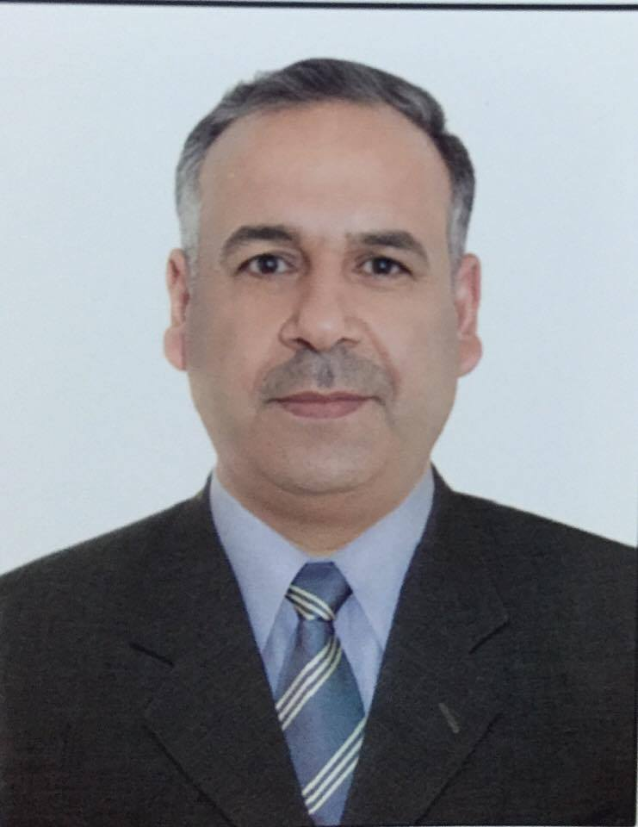

- Personal information:
Full name: - Ahmed Mohammed Ahmed Al-zydi

Academic position: Lecturer
General specialization: Communication engineering
Specific specialization: Digital communication\ Advance Digital Communication\ Error control coding.
Nationality: Iraqi
Gender: Male
Permanent Address: Iraq-diyala- Baqubah
Date of Birth: 7 august 1975

Mobile: 009647712998283

E-mail: ahmedzydi@engineering.uodiyala.edu.iq and ahmed_zydi@yahoo.com & ahmedzydi@gmail.com

- Education Qualification:
- M.Sc. Degree in Communication Engineering, UNITEN University, Malaysia, 2013.
- B.Sc. Degree in Electrical (Electronic & Communication) Engineering- University of Technology-Baghdad, Iraq, 2006.

- Other Education:
- Intensive English Course (IKAL, UNITEN, Malaysia. 2010. )

- Academic Experience:
Currently
- Lecturer (Communication System II, Computer Networking) at the Electronic Engineering Department, College of Engineering, Diyala University.

2013/2017
- Lecturer (Information Theory, Digital Communication System) at the Communication Engineering Department, College of Engineering, Diyala University.

2010/2013
- Doing M.Sc. Degree in Communication Engineering, UNITEN University, Malaysia.

2007 – 2010
- In charge labs. Of communication engineering department, college of engineering, Diyala University.
- Working in digital communication Lab. And Electronic Lab.

- Further I worked and still working in the following fields:
- Programming several scientific projects using MATLAB Tool.
- Very good experience in MS. Office; MS. Excel, MS Power Point and MS Word.
- Experience certificate installing and qualifying laboratories (Communication -Electronic) and installing Electronic trunk exchange from Scientific and consultative office in Diyala University.

5. Research interest:
- Digital communication system
- Error control coding

6. Publication:
- Arifin, Nurul Farahin Bt Tajul; Othman, Noor Shamsiah; Ahmed, Ahmed Mohammed, "Overcomplete source expansion aided, soft-bit assisted speech transceiver," in Telecommunication Technologies (ISTT), 2014 IEEE 2nd International Symposium on , vol., no., pp.326-329, 24-26 Nov. 2014.
- Ahmed Mohammed Ahmed et al,” The Impact of Digital Communication on Social Networks: A Review” International Journal of Computer Science and Mobile Computing, Vol.5 Issue.1, January- 2016, pg. 183-190
- Ahmed Mohammed Ahmed, " BER Improvement Using Error Concealment Technique for Pulse Code Modulation System" Diyala Journal of Engineering Sciences, Vol. 11, No. 1, March 2018, pages 61-63
- Israa Ali, Ahmed Ahmed, Huda Hamd"Reflection Coefficient Measurements Experimentally and Simulation of Epoxy-Polyester in X- Band Frequencies" Jour of Adv Research in Dynamical & Control Systems, Vol. 10, 04-Special Issue, 2018
- A. M. Ahmed, “Specific Absorption Rate (SAR) Simulated for Square Patch Antenna of Head Tissues,” Engineering and Technology Journal, Vol. 36,Part A, No. 5, pp. 509-513, 2018.

